DBT- Auto Script Generation

Chowdam Sireesha, Member Technical staff

Keywords: Data Build Tool (dbt), Features of DBT, Basics of a dbt project, You Have to Code, Installation Steps for Dbt CLI, DBT Project, Using DBT data Transforming to Warehouse, Converting a Simple Script into Dbt Template Project, Benefits of Data Build Tool, References

Data Build Tool (dbt)
- A data transformation tool called dbt (data build tool) employs a few specific SQL commands.
- We may build intricate models, employ variables and macros, run tests, produce documentation, and use many other capabilities.
- The T in ELT (Extract, Load, Transform) procedures is performed by dbt, which does not extract or load data but is effective at transforming data that is already there in the database.
- With the help of the open-source transform tool dbt, anyone who is familiar with SQL can create their own data pipelines.

Features of DBT
dbt makes use of Jinja, custom Jinja extensions. It provides the complete programming environment to write SQL-based data transformation logic against a data warehouse
1. A dbt user only needs to focus on writing select queries. dbt takes care of it by:
- Changing the models into objects that reside in your organization’s data warehouse.
- By using the ref function, we can execute a step by step transformation mechanism in an order
2. It also offers a lot of flexibility to the users like data/non data engineers. for example, the resultant project structure is not a match for your organizational needs. You can customize it by editing the dbt_project.yml file or the configuration file and rearranging the folders.

Basics of a dbt project
There are three main things to know about in order to use the dbt tool.
- dbt project
- database connection
- dbt commands

We Have to Code

dbt is a complete Jinja compiler, so anything you can express in Jinja, used to express in dbt code. (like If statements, for loops, filters, macros, and more.)

dbt comes with a combination of three different programming languages

1. sql - for defining data transformations

2. yml - configuring, documenting and testing the transformations

3. jinja - for templeting and lineage

python is in the background stretching these together.

we adopt jinja in to our modelling process to make a code more powerful, moderate.

jinja is a simple pythonic templating engine.

In fact, if you've used the {{ref () }} function, you're already using Jinja!

Installation Steps for Dbt CLI

Dbt CLI

You can install the dbt command-line interface (CLI) by following the instructions on the following dbt documentation page.
- Dbt CLI is a open source and free to use
- dbt Core ships with a command-line interface (CLI) for running your dbt project.
- use pip to install dbt Core on Windows or Linux operating systems.
- Windows requires Python and git to successfully install and run dbt Core.
- As of v1.0.0, dbt-core is compatible with Python versions 3.7, 3.8, and 3.9.- version of Python.
- dbt installations are tested using the latest versions of pip and setup tools
- pip install dbt is no longer supported and will raise an explicit error
- pip install dbt-core
- commands for cloning the repository
- git clone https://github.com/username/demo_dbt.git
- than we need to give dbt init demo_dbt
- then the dbt project got created and is ready to use
- Python: Python versions 3.7, 3.8, and 3.9. needed
- Warehouse: a data warehouse like Snowflake, synapse, redshift needed

DBT Project
A dbt_project.yml file tells dbt that a particular directory is a dbt project.
- A dbt project is a directory containing .sql and. yml files. The minimum required files are:
- A project file named dbt_project.yml This file contains configurations of a dbt project.
- Model(s) (.sql files): A model in dbt is simply a single .sql file containing a single select statement.
- sample_dbt_project

├──README.md
├──analysis
├──data
├──dbt_project.yml
├──macros
├──models
│└──example
│├──my_first_dbt_model.sql
│├──my_second_dbt_model.sql
│└──schema.yml
├──snapshots
└── tests

- dbt_project.yml is the description of the project’s global settings.
- models are the directory with the description of models we will work with.

Using DBT data Transforming to Warehouse:
Snowflake is a data warehouse hosted as a Software-as-a-Service (SaaS) which is faster, user friendly, and more flexible. Snowflake’s data warehouse is developed using a SQL database engine. DBT is an open source tool that is used to manage the ELT load in Snowflake. DBT can be used with Snowflake for the following features.
- Converting tables to views — It is sufficient to change the materialization in a single config file to change a table to a view.
- Stored Procedure — The stored procedures created in dbt are shown in the models, which could be accessed and modified.
- Here, we write the Jinja Function in Dbt to transform the data to Snowflake warehouse
- The Transformed data can be shown in warehouse as Tables and Views.
- View: The model is built as a View in the database.
- Tables: The model is built as a table in the database.
Converting a Simple Script into Dbt Template Project:
- Here we are converting the simple sql select script in to the dbt project template.
- Dbt project template which contains dbt_project.yml file, yml files and sql files.
- We are taking a simple select sql script file and converting it in to jinja sql script file by giving required/suitable database and warehouse.

SELECT order_date,
id,
user_id,
status
From "PRODUCTION_DB"."PUBLIC"."ORDERS"
Where user_id=1

- Here, we are taking the Simple select sql script and converting it in to Jinja sql.
with payments as
(select *
from {% if var('env_name') == 'production' %} {{ ref('production_payments') }} {% else %} {{ ref('staging_payments') }} {% endif %}),
orders as
(select *
from {% if var('env_name') == 'production' %} {{ ref('production_orders') }} {% else %} {{ ref('staging_orders') }} {% endif %}),
final as
(select payments.order_id,
orders.status,
payments.payment_method as prod_stag
from payments
inner join orders on payments.order_id = orders.id)
select * from final

- By running this code along with the schema, project.yml files in Visual Studio code by giving the commands dbt run –target production, dbt run –target staging according to the environment what we have given
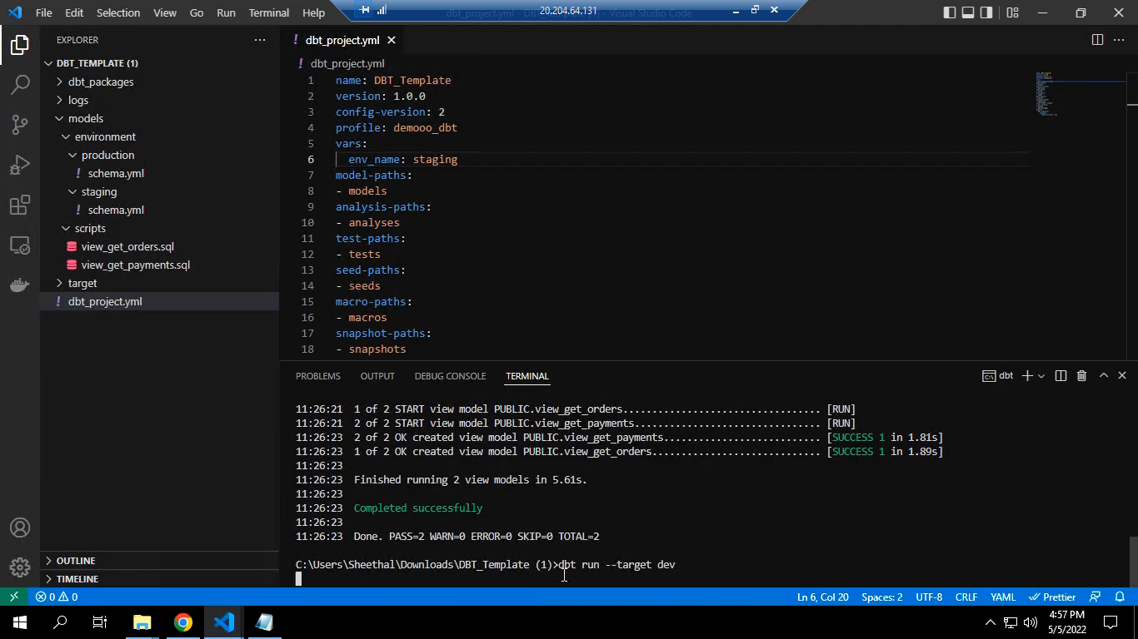
- The result will show in the Snowflake warehouse as Views and Tables.
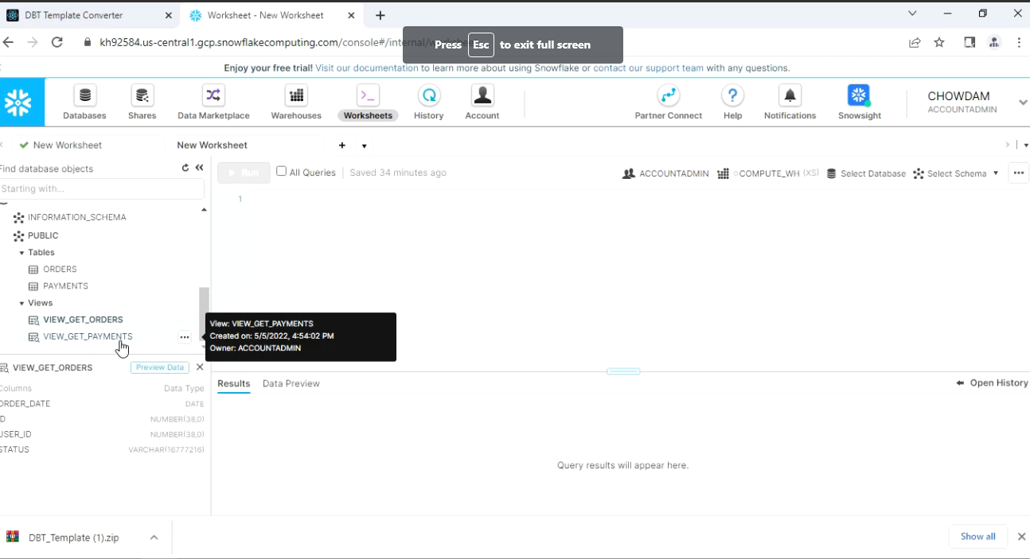

- So, this is how convert Simple Script into jinja sql and Dbt Template Project will works
Benefits of Data Build Tool
- Easy to use for non engineers (shared data knowledge between engineering and non engineering teams)
- Extremely flexible data model (recreate data easily, backfills are easy)
- If most of your transformations are at a data warehouse level, this tool makes it extremely easy to do
- Built in testing for data quality
- Online, searchable data catalog and lineage
- Reusable macros
- Shockingly low learning curve
- Production run using dbt cloud or through Airflow trigger.

References:
- What is dbt? | dbt Docs (getdbt.com)
- CLI overview | DBT Docs (getDBT.com)
- Overview | DBT Docs (getDBT.com)
- Learn analytics engineering with dbt - Transform data in your warehouse (getdbt.com)

Conclusion:
dbt is a great tool for transforming data, capturing documentation, and lineage. Dbt is a great choice to build your ELT pipelines. Combining data warehouse best practices, testing, documentation, ease of use, data CI/CD, community support and a great cloud offering.

About the author:

Chowdam Sireesha holds bachelor’s degree in Computer Science Engineering from SIETK Puttur. She is currently working as Member Technical Staff with ERS Research team and involved in Data Engineering products research & development.
Top of Form
Bottom of Form

